**DAILY ONLINE ACTIVITIES SUMMARY**

|  |  |  |  |  |  |  |  |  |
| --- | --- | --- | --- | --- | --- | --- | --- | --- |
| **Date:** | **12th july,2020** | | | | | **Name:** | **Prathusha K A** | |
| **Sem & Sec** | **4th sem &b section** | | | | | **USN:** | **4AL18CS061** | |
| **Online Test Summary** | | | | | | | | |
| **Subject** | | **------** | | | | | | |
| **Max. Marks** | | **-----** | | **Score** | | | **--------** | |
| **Certification Course Summary** | | | | | | | | |
| **Course** | **Hadoop fundamentals** | | | | | | | |
| **Certificate Provider** | | | **Great learning** | | **Duration** | | | **6 hrs** |
| **Coding Challenges** | | | | | | | | |
| **Problem statement: --------** | | | | | | | | |
| **Status: --------** | | | | | | | | |
| **Uploaded the report in Github** | | | | | **yes** | | | |
| **If yes Repository name** | | | | | **https://github.com/prathu47/lockdown-reports** | | | |
| **Uploaded the report in slack** | | | | | **yes** | | | |

Certification Course Details: (Attach the snapshot and briefly write the report for the same)

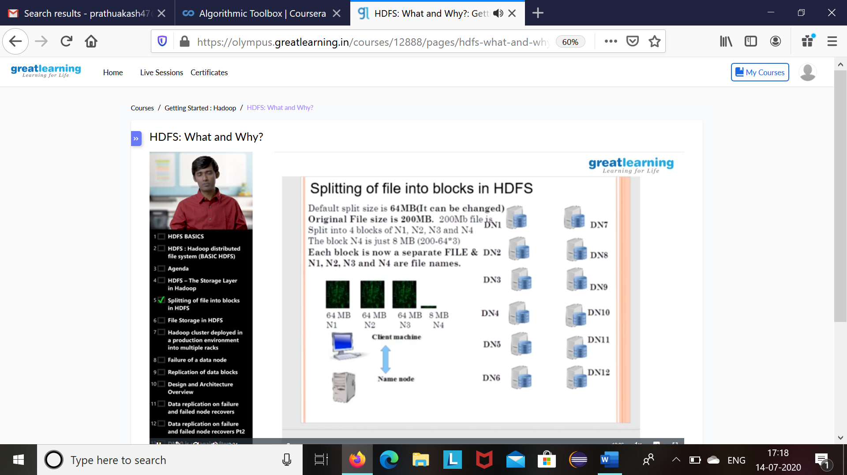

The course I have chosen during the lockdown period is hadoop fundamentals. since I was interested in Hadoop technology I optted for this course . Today learnt about blocks in Hadoop.

Coding Challenges Details: (Attach the snapshot and briefly write the report for the same.

-----------------------------------------------------